Правила землепользования и застройки
муниципального образования
Токсовское городское поселение
Всеволожского муниципального района
ленинградской области

Приложение
Сведения о границах территориальных зон

Санкт-Петербург – Токсово
2018

Посёлок Новое Токсово

Графическое описание местоположения границ территориальных зон
Ж-1. Зона застройки индивидуальными жилыми домами
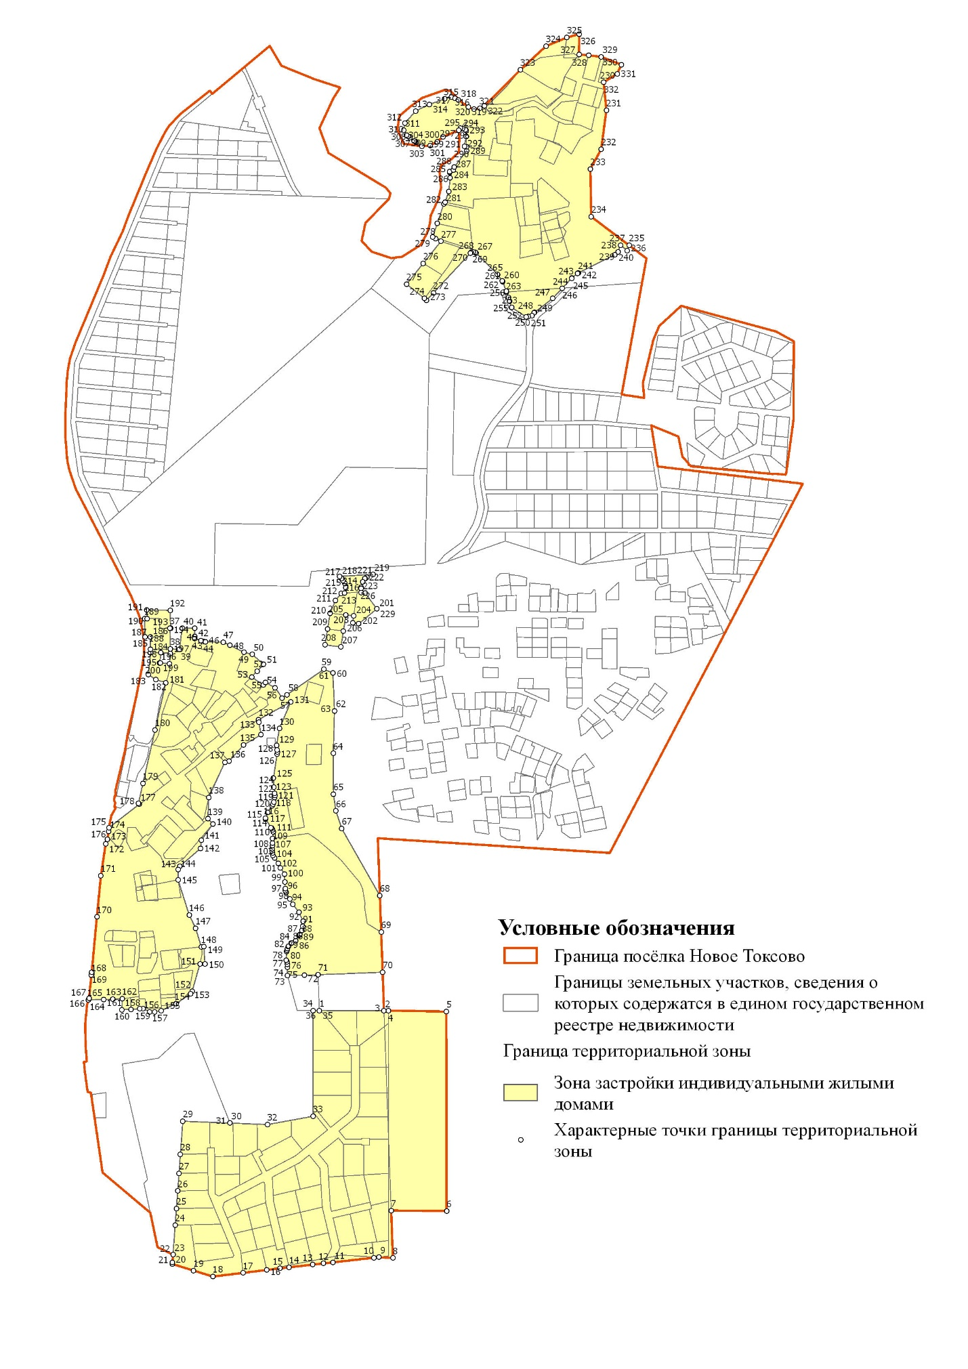
Ж-1-1. Подзона планируемой застройки индивидуальными жилыми домами
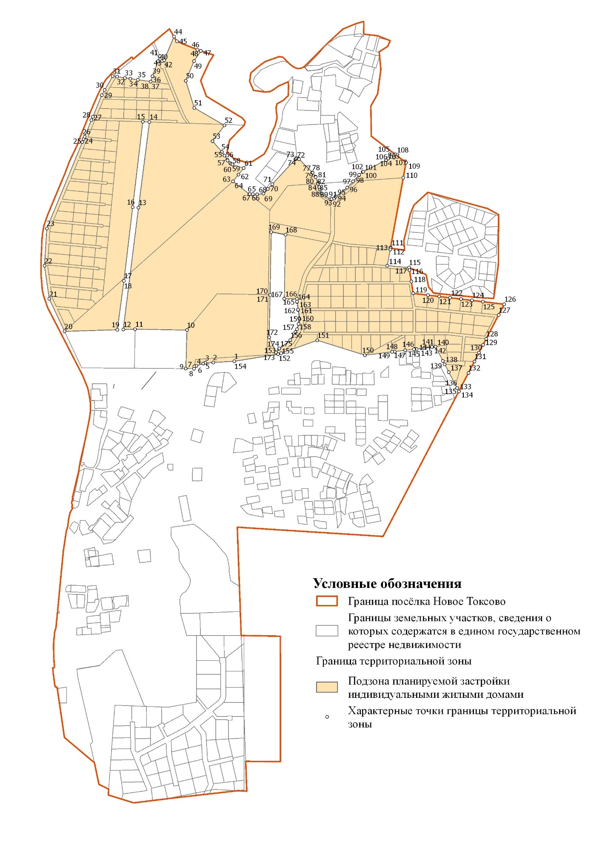

ОД-1. Зона делового, общественного и коммерческого назначения
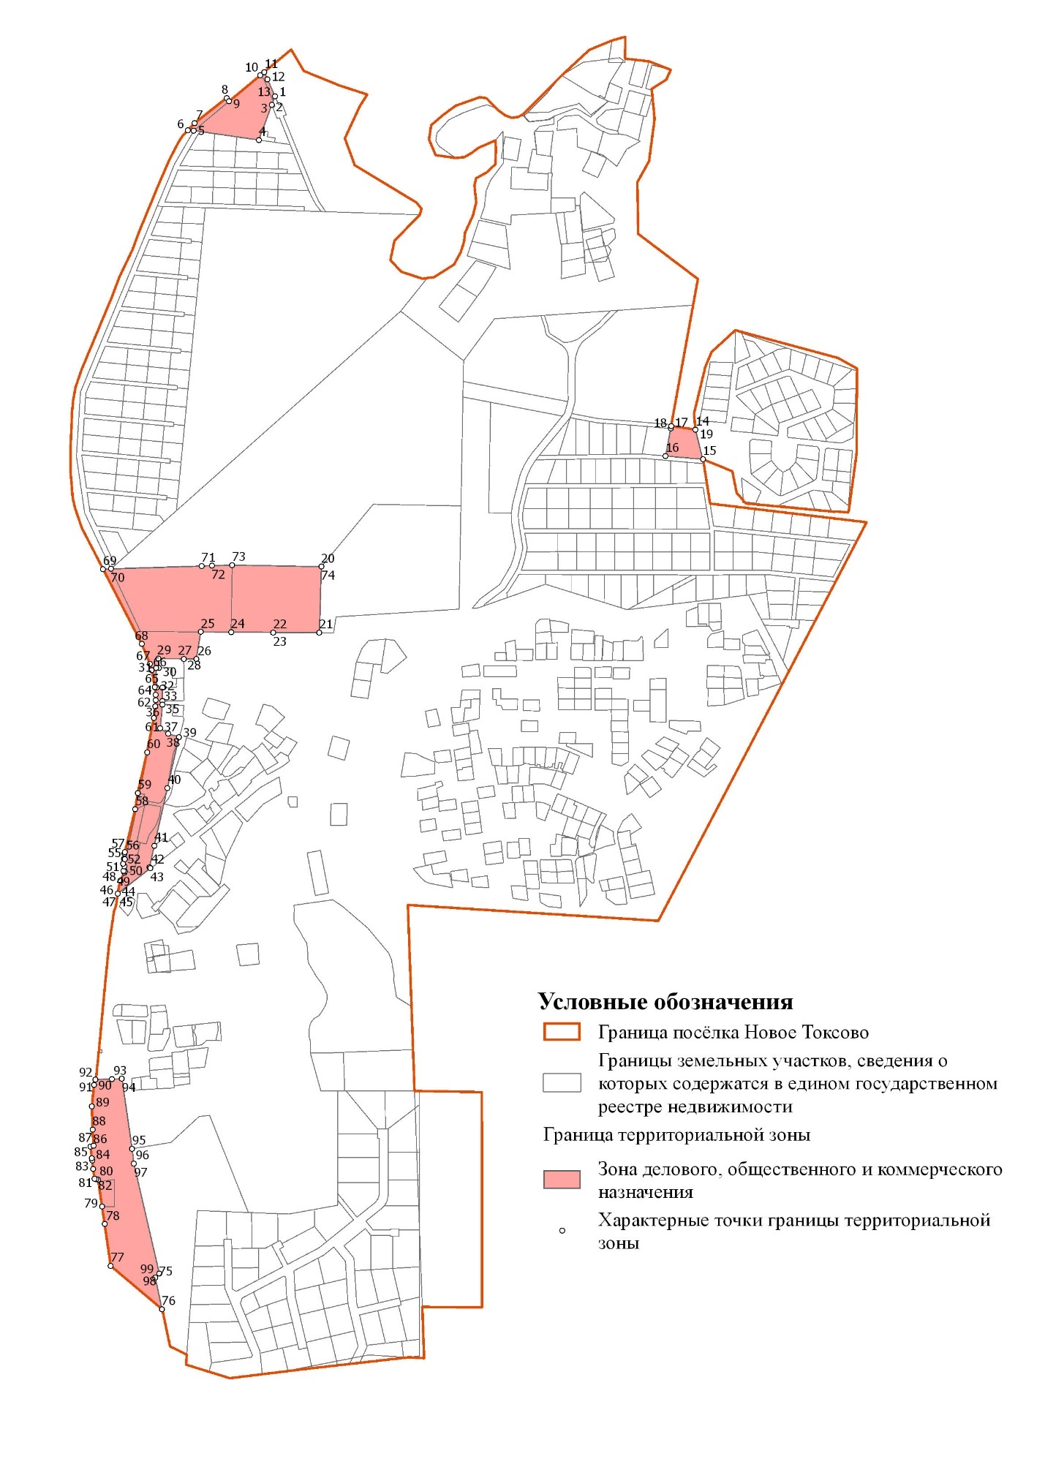

Р-1. Зона зеленых насаждений общего пользования
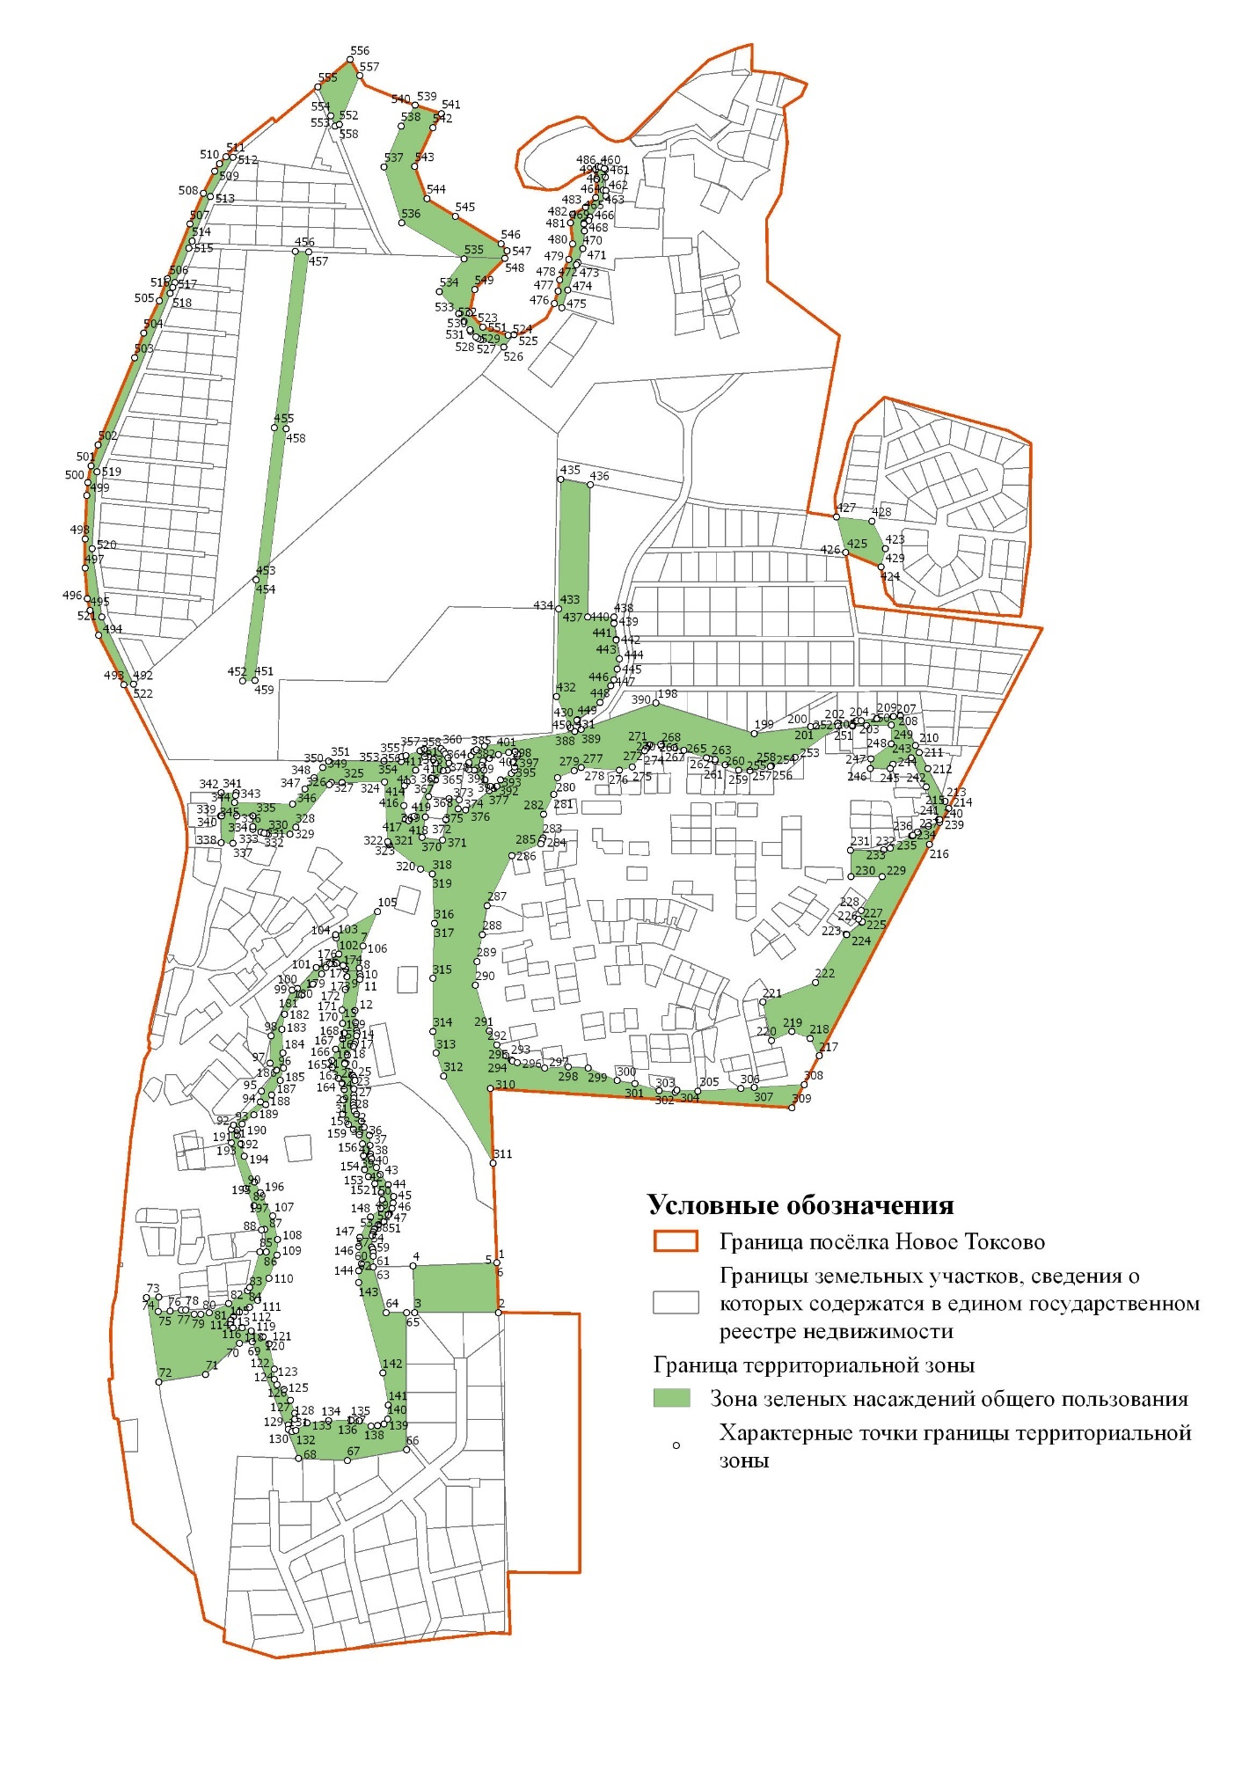

Р-2. Зона лесопаркового зеленого пояса

Р-4. Зона пляжей

ИТ-1. Зона инженерной инфраструктуры

СХ-2. Зона ведения садоводства и огородничества
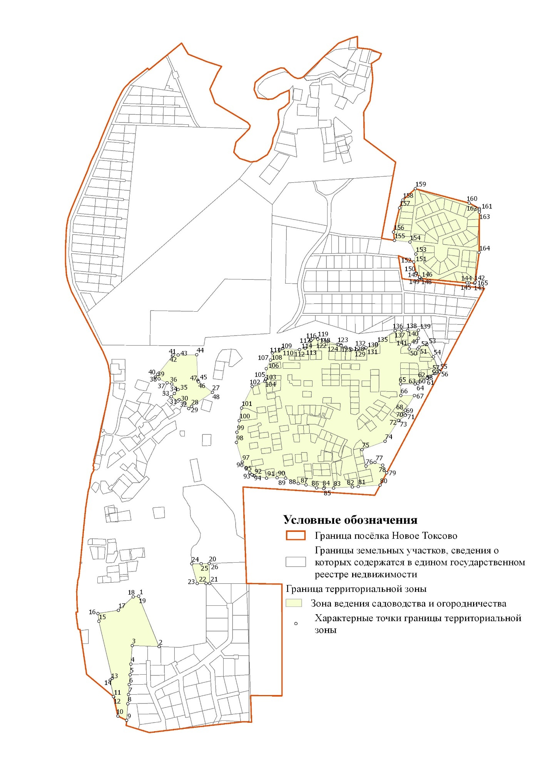

Перечень координат характерных точек границ территориальных зон
Ж-1. Зона застройки индивидуальными жилыми домами

N | Y | X
1 | 127393,15 | 123816,20
2 | 127522,25 | 123815,98
3 | 127522,25 | 123815,97
4 | 127531,00 | 123816,13
5 | 127646,70 | 123814,15
6 | 127647,13 | 123416,58
7 | 127536,55 | 123417,43
8 | 127539,95 | 123322,70
9 | 127511,85 | 123324,37
10 | 127501,90 | 123323,25
11 | 127420,75 | 123314,10
12 | 127401,77 | 123311,95
13 | 127379,95 | 123309,48
14 | 127333,08 | 123304,18
15 | 127315,00 | 123302,13
16 | 127288,52 | 123298,90
17 | 127240,93 | 123293,06
18 | 127180,98 | 123285,70
19 | 127142,25 | 123297,70
20 | 127099,98 | 123310,80
21 | 127100,21 | 123314,00
22 | 127101,35 | 123329,23
23 | 127101,34 | 123329,23
24 | 127105,71 | 123388,27
25 | 127108,15 | 123421,33
26 | 127110,75 | 123456,40
27 | 127113,31 | 123491,46
28 | 127116,12 | 123529,53
29 | 127121,00 | 123595,50
30 | 127215,16 | 123591,75
31 | 127215,15 | 123591,78
32 | 127289,70 | 123588,83
33 | 127380,60 | 123605,30
34 | 127380,70 | 123816,20
35 | 127393,14 | 123816,19
36 | 127393,15 | 123816,20
37 | 127095,18 | 124578,85
38 | 127096,35 | 124537,35
39 | 127114,30 | 124536,40
40 | 127119,53 | 124578,70
41 | 127144,30 | 124578,70
42 | 127144,55 | 124562,43
43 | 127144,63 | 124558,23
44 | 127162,20 | 124552,38
45 | 127157,08 | 124554,08
46 | 127165,80 | 124551,18
47 | 127201,73 | 124550,90
48 | 127215,06 | 124544,37
49 | 127243,08 | 124530,63
50 | 127259,55 | 124526,42
51 | 127281,99 | 124506,52
52 | 127269,12 | 124492,93
53 | 127258,23 | 124481,43
54 | 127281,47 | 124465,21
55 | 127285,72 | 124470,36
56 | 127305,20 | 124460,00
57 | 127319,05 | 124439,40
58 | 127328,83 | 124446,05
59 | 127402,53 | 124496,73
60 | 127420,20 | 124489,45
61 | 127420,55 | 124489,30
62 | 127423,60 | 124413,65
63 | 127423,60 | 124413,50
64 | 127420,93 | 124328,98
65 | 127421,60 | 124247,50
66 | 127426,20 | 124214,18
67 | 127437,95 | 124178,95
68 | 127514,02 | 124045,14
69 | 127516,62 | 123972,58
70 | 127519,49 | 123892,63
71 | 127390,78 | 123887,55
72 | 127363,11 | 123886,47
73 | 127329,61 | 123886,43
74 | 127329,60 | 123886,43
75 | 127329,82 | 123902,27
76 | 127329,89 | 123907,92
77 | 127328,36 | 123912,95
78 | 127327,23 | 123916,65
79 | 127328,03 | 123934,13
80 | 127328,55 | 123936,38
81 | 127329,68 | 123939,70
82 | 127331,35 | 123943,68
83 | 127332,40 | 123945,00
84 | 127337,03 | 123950,60
85 | 127337,55 | 123950,95
86 | 127346,03 | 123955,50
87 | 127352,88 | 123965,95
88 | 127353,43 | 123967,13
89 | 127354,00 | 123967,88
90 | 127358,40 | 123975,65
91 | 127360,28 | 123984,45
92 | 127360,65 | 123994,30
93 | 127352,50 | 124012,33
94 | 127340,58 | 124028,10
95 | 127334,48 | 124038,55
96 | 127326,80 | 124051,63
97 | 127325,80 | 124054,88
98 | 127325,10 | 124059,75
99 | 127324,75 | 124072,45
100 | 127323,40 | 124088,60
101 | 127315,88 | 124100,68
102 | 127311,40 | 124109,35
103 | 127304,20 | 124120,48
104 | 127301,10 | 124125,55
105 | 127299,60 | 124130,75
106 | 127299,08 | 124134,35
107 | 127299,20 | 124138,53
108 | 127299,80 | 124145,20
109 | 127300,05 | 124150,50
110 | 127299,65 | 124159,38
111 | 127301,30 | 124172,25
112 | 127300,03 | 124176,23
113 | 127297,93 | 124179,85
114 | 127296,95 | 124181,05
115 | 127286,20 | 124198,00
116 | 127286,10 | 124200,00
117 | 127289,98 | 124211,30
118 | 127298,95 | 124224,55
119 | 127301,03 | 124228,15
120 | 127302,33 | 124232,13
121 | 127304,35 | 124240,80
122 | 127304,80 | 124244,95
123 | 127304,35 | 124249,10
124 | 127302,70 | 124261,63
125 | 127301,78 | 124279,73
126 | 127308,95 | 124327,30
127 | 127309,38 | 124331,48
128 | 127308,95 | 124335,63
129 | 127307,75 | 124344,90
130 | 127313,63 | 124378,53
131 | 127336,41 | 124431,84
132 | 127272,02 | 124396,25
133 | 127272,78 | 124391,55
134 | 127276,83 | 124366,20
135 | 127242,25 | 124345,73
136 | 127213,13 | 124313,45
137 | 127204,63 | 124311,28
138 | 127172,68 | 124241,03
139 | 127170,78 | 124198,60
140 | 127180,88 | 124188,28
141 | 127157,73 | 124155,75
142 | 127156,63 | 124139,78
143 | 127114,95 | 124103,83
144 | 127111,60 | 124097,10
145 | 127111,45 | 124076,83
146 | 127133,80 | 124006,40
147 | 127146,58 | 123980,20
148 | 127157,78 | 123943,15
149 | 127162,85 | 123943,68
150 | 127165,33 | 123909,08
151 | 127155,18 | 123909,40
152 | 127139,53 | 123854,55
153 | 127136,18 | 123849,85
154 | 127107,53 | 123829,83
155 | 127078,03 | 123816,25
156 | 127064,93 | 123813,55
157 | 127054,85 | 123813,55
158 | 127041,38 | 123819,95
159 | 127034,70 | 123819,58
160 | 127017,70 | 123818,65
161 | 126999,65 | 123817,70
162 | 126999,80 | 123839,55
163 | 126981,63 | 123838,83
164 | 126962,93 | 123838,30
165 | 126932,89 | 123837,43
166 | 126932,88 | 123837,41
167 | 126933,85 | 123840,60
168 | 126938,65 | 123887,17
169 | 126939,25 | 123892,63
170 | 126949,48 | 124002,88
171 | 126957,58 | 124085,10
172 | 126966,95 | 124148,15
173 | 126970,42 | 124157,40
174 | 126972,82 | 124173,00
175 | 126973,40 | 124180,70
176 | 126973,39 | 124180,53
177 | 127034,05 | 124227,60
178 | 127032,53 | 124229,38
179 | 127041,35 | 124269,23
180 | 127065,60 | 124375,90
181 | 127086,95 | 124470,03
182 | 127067,03 | 124475,95
183 | 127052,53 | 124485,98
184 | 127056,35 | 124530,25
185 | 127056,70 | 124536,23
186 | 127056,03 | 124560,88
187 | 127056,00 | 124561,50
188 | 127045,65 | 124561,30
189 | 127044,65 | 124597,55
190 | 127049,75 | 124597,70
191 | 127049,28 | 124614,70
192 | 127095,65 | 124614,38
193 | 127096,65 | 124578,90
194 | 127095,18 | 124578,85
195 | 127076,33 | 124509,18
196 | 127094,18 | 124507,68
197 | 127096,10 | 124528,35
198 | 127077,33 | 124529,58
199 | 127074,65 | 124509,65
200 | 127076,33 | 124509,18
201 | 127507,73 | 124617,10
202 | 127471,98 | 124587,53
203 | 127459,60 | 124589,40
204 | 127461,73 | 124603,25
205 | 127446,30 | 124604,90
206 | 127441,25 | 124572,95
207 | 127436,30 | 124541,15
208 | 127404,55 | 124545,35
209 | 127409,70 | 124576,95
210 | 127414,73 | 124608,65
211 | 127425,35 | 124634,00
212 | 127437,15 | 124648,00
213 | 127443,38 | 124648,53
214 | 127445,73 | 124659,25
215 | 127444,00 | 124667,40
216 | 127440,19 | 124673,80
217 | 127438,08 | 124677,35
218 | 127433,20 | 124682,03
219 | 127500,35 | 124685,78
220 | 127500,36 | 124685,77
221 | 127488,08 | 124680,08
222 | 127484,65 | 124677,98
223 | 127484,18 | 124677,30
224 | 127479,80 | 124670,90
225 | 127476,70 | 124660,70
226 | 127476,18 | 124657,78
227 | 127476,93 | 124649,63
228 | 127485,08 | 124648,55
229 | 127507,73 | 124617,10
230 | 127960,48 | 125667,13
231 | 127965,80 | 125611,45
232 | 127955,55 | 125533,80
233 | 127933,77 | 125494,40
234 | 127935,65 | 125399,20
235 | 128011,29 | 125342,01
236 | 128007,48 | 125331,88
237 | 127993,80 | 125342,40
238 | 127993,80 | 125342,38
239 | 127989,08 | 125329,35
240 | 127982,90 | 125323,45
241 | 127909,70 | 125287,00
242 | 127909,28 | 125286,78
243 | 127908,20 | 125286,03
244 | 127897,08 | 125276,88
245 | 127896,33 | 125276,18
246 | 127878,02 | 125256,75
247 | 127858,90 | 125236,45
248 | 127822,78 | 125208,48
249 | 127821,60 | 125207,38
250 | 127817,11 | 125202,16
251 | 127810,29 | 125199,91
252 | 127806,08 | 125199,30
253 | 127776,60 | 125218,43
254 | 127773,00 | 125230,68
255 | 127772,88 | 125231,08
256 | 127770,43 | 125238,08
257 | 127766,56 | 125249,11
258 | 127766,20 | 125250,13
259 | 127766,18 | 125250,20
260 | 127759,18 | 125269,43
261 | 127758,97 | 125269,88
262 | 127758,83 | 125270,28
263 | 127758,58 | 125270,70
264 | 127758,05 | 125271,50
265 | 127748,98 | 125283,60
266 | 127748,23 | 125284,45
267 | 127705,98 | 125326,63
268 | 127704,33 | 125327,90
269 | 127700,33 | 125328,98
270 | 127696,33 | 125327,90
271 | 127694,48 | 125326,43
272 | 127620,93 | 125247,43
273 | 127607,13 | 125232,63
274 | 127603,18 | 125236,15
275 | 127567,18 | 125264,65
276 | 127600,65 | 125306,25
277 | 127635,85 | 125350,05
278 | 127625,05 | 125355,78
279 | 127619,50 | 125358,73
280 | 127628,43 | 125385,55
281 | 127641,40 | 125424,60
282 | 127644,00 | 125428,35
283 | 127651,40 | 125449,65
284 | 127654,32 | 125476,39
285 | 127653,18 | 125487,53
286 | 127653,48 | 125488,85
287 | 127660,22 | 125492,58
288 | 127662,50 | 125498,15
289 | 127686,83 | 125530,70
290 | 127686,65 | 125538,56
291 | 127682,60 | 125539,27
292 | 127686,17 | 125559,58
293 | 127685,92 | 125570,66
294 | 127684,40 | 125572,18
295 | 127678,83 | 125575,03
296 | 127674,79 | 125575,80
297 | 127671,70 | 125572,03
298 | 127671,70 | 125572,02
299 | 127640,25 | 125558,15
300 | 127628,02 | 125548,90
301 | 127614,20 | 125541,02
302 | 127597,83 | 125539,57
303 | 127597,81 | 125539,58
304 | 127586,21 | 125547,89
305 | 127597,83 | 125539,58
306 | 127584,50 | 125549,11
307 | 127582,43 | 125550,59
308 | 127573,92 | 125556,67
309 | 127570,45 | 125559,15
310 | 127567,03 | 125561,60
311 | 127561,45 | 125571,50
312 | 127563,65 | 125585,93
313 | 127585,75 | 125610,00
314 | 127612,75 | 125623,23
315 | 127643,30 | 125634,15
316 | 127656,35 | 125637,73
317 | 127663,57 | 125634,96
318 | 127670,80 | 125632,20
319 | 127689,95 | 125618,05
320 | 127701,77 | 125613,75
321 | 127713,65 | 125615,30
322 | 127722,45 | 125620,05
323 | 127794,07 | 125692,00
324 | 127845,18 | 125739,20
325 | 127887,20 | 125756,55
326 | 127911,45 | 125763,37
327 | 127911,32 | 125722,95
328 | 127930,15 | 125720,82
329 | 127955,30 | 125718,00
330 | 127995,65 | 125702,27
331 | 127987,20 | 125684,10
332 | 127960,48 | 125667,13

Ж-1-1. Подзона планируемой застройки индивидуальными жилыми домами

N | Y | X
1 | 127500,35 | 124685,78
2 | 127433,20 | 124682,03
3 | 127408,25 | 124680,65
4 | 127401,50 | 124678,40
5 | 127401,55 | 124678,43
6 | 127379,72 | 124671,25
7 | 127373,68 | 124669,15
8 | 127372,61 | 124662,39
9 | 127346,50 | 124662,58
10 | 127350,01 | 124784,63
11 | 127185,43 | 124787,64
12 | 127147,68 | 124786,45
13 | 127196,15 | 125173,05
14 | 127230,86 | 125444,47
15 | 127209,66 | 125445,16
16 | 127177,65 | 125174,80
17 | 127149,83 | 124941,20
18 | 127149,83 | 124941,10
19 | 127128,85 | 124785,85
20 | 126961,32 | 124780,56
21 | 126912,75 | 124883,67
22 | 126897,45 | 124988,62
23 | 126904,97 | 125107,19
24 | 127017,93 | 125380,74
25 | 127021,76 | 125390,02
26 | 127025,00 | 125397,88
27 | 127046,73 | 125450,50
28 | 127051,13 | 125461,15
29 | 127079,25 | 125529,25
30 | 127088,93 | 125545,94
31 | 127114,51 | 125590,02
32 | 127127,82 | 125588,10
33 | 127152,82 | 125584,49
34 | 127170,04 | 125582,00
35 | 127193,96 | 125578,54
36 | 127234,35 | 125572,70
37 | 127234,35 | 125572,71
38 | 127234,36 | 125572,71
39 | 127240,71 | 125589,83
40 | 127258,46 | 125637,66
41 | 127264,36 | 125653,57
42 | 127271,25 | 125638,01
43 | 127277,21 | 125640,10
44 | 127308,90 | 125715,03
45 | 127317,63 | 125700,22
46 | 127383,35 | 125673,48
47 | 127394,35 | 125669,90
48 | 127394,33 | 125669,90
49 | 127372,33 | 125637,83
50 | 127346,30 | 125575,15
51 | 127373,10 | 125489,50
52 | 127469,15 | 125433,60
53 | 127431,28 | 125383,83
54 | 127461,08 | 125350,00
55 | 127469,33 | 125338,10
56 | 127478,13 | 125324,90
57 | 127478,95 | 125322,65
58 | 127487,23 | 125314,13
59 | 127490,60 | 125311,68
60 | 127494,43 | 125309,98
61 | 127529,98 | 125298,13
62 | 127513,48 | 125277,67
63 | 127496,23 | 125256,28
64 | 127496,59 | 125256,60
65 | 127548,51 | 125215,71
66 | 127549,13 | 125215,70
67 | 127558,77 | 125215,54
68 | 127573,25 | 125215,30
69 | 127593,15 | 125217,60
70 | 127607,13 | 125232,63
71 | 127620,93 | 125247,43
72 | 127694,48 | 125326,43
73 | 127696,33 | 125327,90
74 | 127700,33 | 125328,98
75 | 127704,33 | 125327,90
76 | 127705,98 | 125326,63
77 | 127748,23 | 125284,45
78 | 127748,98 | 125283,60
79 | 127758,05 | 125271,50
80 | 127758,58 | 125270,70
81 | 127758,83 | 125270,28
82 | 127758,97 | 125269,88
83 | 127759,18 | 125269,43
84 | 127766,18 | 125250,20
85 | 127766,20 | 125250,13
86 | 127766,56 | 125249,11
87 | 127770,43 | 125238,08
88 | 127772,88 | 125231,08
89 | 127773,00 | 125230,68
90 | 127776,60 | 125218,43
91 | 127806,08 | 125199,30
92 | 127810,29 | 125199,91
93 | 127817,11 | 125202,16
94 | 127821,60 | 125207,38
95 | 127822,78 | 125208,48
96 | 127858,90 | 125236,45
97 | 127878,02 | 125256,75
98 | 127896,33 | 125276,18
99 | 127897,08 | 125276,88
100 | 127908,20 | 125286,03
101 | 127909,28 | 125286,78
102 | 127909,70 | 125287,00
103 | 127982,90 | 125323,45
104 | 127989,08 | 125329,35
105 | 127993,80 | 125342,38
106 | 127993,80 | 125342,40
107 | 128007,48 | 125331,88
108 | 128011,29 | 125342,01
109 | 128045,75 | 125315,95
110 | 128036,96 | 125267,70
111 | 127996,75 | 125047,00
112 | 127996,30 | 125044,61
113 | 127995,43 | 125039,81
114 | 127986,13 | 124989,03
115 | 128054,80 | 124983,00
116 | 128055,40 | 124982,95
117 | 128056,68 | 124974,87
118 | 128062,38 | 124938,65
119 | 128068,30 | 124901,10
120 | 128115,73 | 124895,45
121 | 128150,75 | 124891,27
122 | 128185,50 | 124887,15
123 | 128220,25 | 124883,00
124 | 128255,00 | 124878,85
125 | 128289,75 | 124874,70
126 | 128357,40 | 124866,65
127 | 128339,62 | 124832,53
128 | 128300,31 | 124757,14
129 | 128290,16 | 124737,68
130 | 128277,45 | 124713,32
131 | 128262,89 | 124685,39
132 | 128243,98 | 124649,13
133 | 128213,38 | 124590,45
134 | 128213,37 | 124590,44
135 | 128213,37 | 124590,45
136 | 128207,75 | 124601,24
137 | 128181,68 | 124651,20
138 | 128168,60 | 124676,27
139 | 128162,88 | 124687,00
140 | 128139,33 | 124732,45
141 | 128128,91 | 124731,18
142 | 128128,16 | 124731,09
143 | 128103,45 | 124728,08
144 | 128079,26 | 124725,14
145 | 128072,75 | 124724,35
146 | 128071,13 | 124724,15
147 | 128042,50 | 124720,65
148 | 128010,02 | 124716,71
149 | 128001,75 | 124715,71
150 | 127915,20 | 124705,18
151 | 127764,07 | 124752,32
152 | 127649,15 | 124711,80
153 | 127639,37 | 124708,37
154 | 127500,35 | 124685,78
155 | 127643,63 | 124726,30
156 | 127678,20 | 124752,80
157 | 127694,15 | 124778,23
158 | 127699,00 | 124787,43
159 | 127704,45 | 124804,35
160 | 127707,53 | 124819,45
161 | 127702,90 | 124848,83
162 | 127702,88 | 124849,05
163 | 127699,68 | 124873,90
164 | 127699,60 | 124874,93
165 | 127699,60 | 124875,03
166 | 127699,70 | 124883,80
167 | 127659,08 | 124884,10
168 | 127662,80 | 125086,78
169 | 127617,60 | 125095,68
170 | 127613,98 | 124896,80
171 | 127613,98 | 124896,78
172 | 127611,10 | 124762,25
173 | 127632,95 | 124714,15
174 | 127642,45 | 124725,18
175 | 127643,63 | 124726,30

ОД-1. Зона делового, общественного и коммерческого назначения

N | Y | X
1 | 127264,33 | 125653,63
2 | 127258,50 | 125637,58
3 | 127258,46 | 125637,66
4 | 127234,35 | 125572,70
5 | 127114,50 | 125590,03
6 | 127103,63 | 125590,90
7 | 127115,98 | 125603,95
8 | 127174,93 | 125650,48
9 | 127179,60 | 125644,20
10 | 127236,88 | 125691,88
11 | 127244,57 | 125698,27
12 | 127250,40 | 125685,11
13 | 127264,33 | 125653,63
14 | 128041,27 | 125037,80
15 | 128054,80 | 124983,00
16 | 127986,13 | 124989,03
17 | 127995,43 | 125039,81
18 | 127996,30 | 125044,61
19 | 128041,27 | 125037,80
20 | 127350,01 | 124784,63
21 | 127346,50 | 124662,58
22 | 127261,46 | 124663,18
23 | 127261,45 | 124663,18
24 | 127183,16 | 124663,74
25 | 127127,36 | 124664,14
26 | 127118,78 | 124614,00
27 | 127095,68 | 124614,38
28 | 127095,65 | 124614,38
29 | 127049,28 | 124614,70
30 | 127049,75 | 124597,70
31 | 127044,65 | 124597,55
32 | 127045,65 | 124561,30
33 | 127056,00 | 124561,50
34 | 127056,03 | 124560,88
35 | 127056,70 | 124536,23
36 | 127056,35 | 124530,25
37 | 127052,53 | 124485,98
38 | 127067,03 | 124475,95
39 | 127086,95 | 124470,03
40 | 127065,60 | 124375,90
41 | 127041,35 | 124269,23
42 | 127032,53 | 124229,38
43 | 127034,05 | 124227,60
44 | 126973,39 | 124180,53
45 | 126973,40 | 124180,70
46 | 126973,40 | 124180,72
47 | 126973,40 | 124180,72
48 | 126978,37 | 124204,90
49 | 126986,50 | 124219,30
50 | 126986,85 | 124221,95
51 | 126984,48 | 124222,45
52 | 126986,20 | 124230,73
53 | 126983,60 | 124235,80
54 | 126985,50 | 124245,03
55 | 126987,30 | 124244,63
56 | 126986,25 | 124254,80
57 | 126987,07 | 124257,30
58 | 127006,00 | 124336,40
59 | 127010,80 | 124366,35
60 | 127027,98 | 124441,65
61 | 127040,53 | 124505,32
62 | 127043,32 | 124526,35
63 | 127043,65 | 124538,47
64 | 127043,70 | 124548,28
65 | 127042,40 | 124561,93
66 | 127036,75 | 124593,25
67 | 127033,45 | 124604,77
68 | 127018,25 | 124641,82
69 | 126946,83 | 124780,02
70 | 126961,32 | 124780,56
71 | 127128,85 | 124785,85
72 | 127147,68 | 124786,45
73 | 127185,43 | 124787,64
74 | 127350,01 | 124784,63
75 | 127043,23 | 123472,03
76 | 127055,49 | 123413,40
77 | 126960,85 | 123493,23
78 | 126949,52 | 123570,92
79 | 126944,88 | 123602,75
80 | 126937,50 | 123652,53
81 | 126934,38 | 123653,20
82 | 126931,15 | 123653,95
83 | 126928,48 | 123672,25
84 | 126926,58 | 123687,85
85 | 126925,65 | 123692,25
86 | 126923,70 | 123713,88
87 | 126929,28 | 123714,75
88 | 126927,22 | 123745,15
89 | 126926,10 | 123787,60
90 | 126929,95 | 123827,77
91 | 126932,88 | 123837,41
92 | 126932,89 | 123837,43
93 | 126962,93 | 123838,30
94 | 126981,63 | 123838,83
95 | 127000,40 | 123709,63
96 | 127000,40 | 123709,62
97 | 127003,75 | 123681,75
98 | 127050,63 | 123479,30
99 | 127043,23 | 123472,03

Р-1. Зона зеленых насаждений общего пользования

N | Y | X
1 | 127519,50 | 123892,63
2 | 127522,25 | 123815,98
3 | 127393,15 | 123816,20
4 | 127390,78 | 123887,55
5 | 127519,49 | 123892,63
6 | 127519,50 | 123892,63
7 | 127313,63 | 124378,53
8 | 127307,75 | 124344,90
9 | 127308,95 | 124335,63
10 | 127309,38 | 124331,48
11 | 127308,95 | 124327,30
12 | 127301,78 | 124279,73
13 | 127302,70 | 124261,63
14 | 127304,35 | 124249,10
15 | 127304,80 | 124244,95
16 | 127304,35 | 124240,80
17 | 127302,33 | 124232,13
18 | 127301,03 | 124228,15
19 | 127298,95 | 124224,55
20 | 127289,98 | 124211,30
21 | 127286,10 | 124200,00
22 | 127286,20 | 124198,00
23 | 127296,95 | 124181,05
24 | 127297,93 | 124179,85
25 | 127300,03 | 124176,23
26 | 127301,30 | 124172,25
27 | 127299,65 | 124159,38
28 | 127300,05 | 124150,50
29 | 127299,80 | 124145,20
30 | 127299,20 | 124138,53
31 | 127299,08 | 124134,35
32 | 127299,60 | 124130,75
33 | 127301,10 | 124125,55
34 | 127304,20 | 124120,48
35 | 127311,40 | 124109,35
36 | 127315,88 | 124100,68
37 | 127323,40 | 124088,60
38 | 127324,75 | 124072,45
39 | 127325,10 | 124059,75
40 | 127325,80 | 124054,88
41 | 127326,80 | 124051,63
42 | 127334,48 | 124038,55
43 | 127340,58 | 124028,10
44 | 127352,50 | 124012,33
45 | 127360,65 | 123994,30
46 | 127360,28 | 123984,45
47 | 127358,40 | 123975,65
48 | 127354,00 | 123967,88
49 | 127353,43 | 123967,13
50 | 127352,88 | 123965,95
51 | 127346,03 | 123955,50
52 | 127337,55 | 123950,95
53 | 127337,03 | 123950,60
54 | 127332,40 | 123945,00
55 | 127331,35 | 123943,68
56 | 127329,68 | 123939,70
57 | 127328,55 | 123936,38
58 | 127328,03 | 123934,13
59 | 127327,23 | 123916,65
60 | 127328,36 | 123912,95
61 | 127329,89 | 123907,92
62 | 127329,82 | 123902,27
63 | 127329,60 | 123886,43
64 | 127349,13 | 123816,20
65 | 127380,70 | 123816,20
66 | 127380,60 | 123605,30
67 | 127289,70 | 123588,83
68 | 127215,15 | 123591,78
69 | 127143,50 | 123771,35
70 | 127124,08 | 123768,98
71 | 127072,28 | 123721,20
72 | 127000,40 | 123709,63
73 | 126981,63 | 123838,83
74 | 126999,80 | 123839,55
75 | 126999,65 | 123817,70
76 | 127017,70 | 123818,65
77 | 127034,70 | 123819,58
78 | 127041,38 | 123819,95
79 | 127054,85 | 123813,55
80 | 127064,93 | 123813,55
81 | 127078,03 | 123816,25
82 | 127107,53 | 123829,83
83 | 127136,18 | 123849,85
84 | 127139,53 | 123854,55
85 | 127155,18 | 123909,40
86 | 127165,33 | 123909,08
87 | 127162,85 | 123943,68
88 | 127157,78 | 123943,15
89 | 127146,58 | 123980,20
90 | 127133,80 | 124006,40
91 | 127111,45 | 124076,83
92 | 127111,60 | 124097,10
93 | 127114,95 | 124103,83
94 | 127156,63 | 124139,78
95 | 127157,73 | 124155,75
96 | 127180,88 | 124188,28
97 | 127170,78 | 124198,60
98 | 127172,68 | 124241,03
99 | 127204,63 | 124311,28
100 | 127213,13 | 124313,45
101 | 127242,25 | 124345,73
102 | 127276,83 | 124366,20
103 | 127272,78 | 124391,55
104 | 127272,02 | 124396,25
105 | 127336,41 | 124431,84
106 | 127313,63 | 124378,53
107 | 127174,85 | 123964,50
108 | 127182,50 | 123928,38
109 | 127181,98 | 123904,30
110 | 127169,28 | 123868,33
111 | 127151,95 | 123835,23
112 | 127140,03 | 123823,85
113 | 127124,10 | 123816,63
114 | 127114,80 | 123809,80
115 | 127110,73 | 123804,70
116 | 127109,73 | 123797,58
117 | 127113,78 | 123792,48
118 | 127128,55 | 123792,48
119 | 127142,30 | 123787,90
120 | 127160,60 | 123778,75
121 | 127169,10 | 123767,88
122 | 127177,93 | 123728,88
123 | 127177,93 | 123713,08
124 | 127181,98 | 123704,95
125 | 127192,18 | 123697,83
126 | 127202,85 | 123681,03
127 | 127208,95 | 123661,18
128 | 127208,95 | 123652,00
129 | 127199,30 | 123643,35
130 | 127199,30 | 123636,75
131 | 127204,90 | 123633,70
132 | 127211,00 | 123635,23
133 | 127228,30 | 123646,40
134 | 127261,38 | 123649,98
135 | 127295,40 | 123651,15
136 | 127308,20 | 123649,98
137 | 127326,03 | 123641,83
138 | 127336,20 | 123642,35
139 | 127346,38 | 123644,88
140 | 127351,48 | 123652,53
141 | 127353,00 | 123673,90
142 | 127344,35 | 123723,78
143 | 127307,20 | 123862,20
144 | 127307,20 | 123880,53
145 | 127311,28 | 123890,70
146 | 127307,65 | 123917,15
147 | 127308,58 | 123931,35
148 | 127325,53 | 123962,45
149 | 127341,30 | 123976,23
150 | 127343,33 | 123989,45
151 | 127341,70 | 124000,00
152 | 127331,88 | 124014,08
153 | 127321,95 | 124024,58
154 | 127316,35 | 124035,78
155 | 127314,33 | 124056,63
156 | 127313,10 | 124075,40
157 | 127308,20 | 124088,70
158 | 127299,43 | 124097,50
159 | 127291,93 | 124104,98
160 | 127282,75 | 124120,75
161 | 127283,28 | 124143,15
162 | 127284,80 | 124158,43
163 | 127281,75 | 124168,10
164 | 127275,63 | 124175,73
165 | 127266,48 | 124192,53
166 | 127265,98 | 124202,70
167 | 127272,08 | 124220,53
168 | 127282,75 | 124236,30
169 | 127284,80 | 124244,95
170 | 127282,75 | 124260,23
171 | 127281,75 | 124280,58
172 | 127286,33 | 124312,13
173 | 127289,38 | 124331,48
174 | 127287,35 | 124343,68
175 | 127283,28 | 124349,28
176 | 127273,10 | 124352,33
177 | 127262,40 | 124351,33
178 | 127257,33 | 124345,73
179 | 127250,70 | 124336,05
180 | 127236,95 | 124320,28
181 | 127220,15 | 124303,48
182 | 127193,75 | 124274,18
183 | 127189,13 | 124250,55
184 | 127191,15 | 124214,63
185 | 127191,65 | 124191,50
186 | 127186,58 | 124172,18
187 | 127173,95 | 124150,15
188 | 127164,18 | 124135,53
189 | 127146,35 | 124119,75
190 | 127128,55 | 124105,50
191 | 127120,40 | 124096,33
192 | 127120,40 | 124088,18
193 | 127126,45 | 124074,75
194 | 127131,55 | 124055,90
195 | 127147,38 | 124016,43
196 | 127156,08 | 124000,00
197 | 127174,85 | 123964,50
198 | 127764,07 | 124752,32
199 | 127915,20 | 124705,18
200 | 128001,75 | 124715,71
201 | 128010,02 | 124716,71
202 | 128042,50 | 124720,65
203 | 128071,13 | 124724,15
204 | 128072,75 | 124724,35
205 | 128079,26 | 124725,14
206 | 128103,45 | 124728,08
207 | 128128,16 | 124731,09
208 | 128128,91 | 124731,18
209 | 128139,33 | 124732,45
210 | 128162,88 | 124687,00
211 | 128168,60 | 124676,27
212 | 128181,68 | 124651,20
213 | 128207,75 | 124601,24
214 | 128213,37 | 124590,45
215 | 128213,37 | 124590,44
216 | 128184,32 | 124534,75
217 | 128014,37 | 124210,16
218 | 128000,48 | 124237,25
219 | 127972,93 | 124247,33
220 | 127941,35 | 124233,88
221 | 127927,90 | 124292,65
222 | 128008,75 | 124322,60
223 | 128055,79 | 124397,27
224 | 128057,23 | 124396,33
225 | 128079,90 | 124414,89
226 | 128080,68 | 124415,90
227 | 128075,36 | 124420,00
228 | 128079,52 | 124433,09
229 | 128111,38 | 124485,50
230 | 128063,63 | 124485,60
231 | 128062,95 | 124526,18
232 | 128114,03 | 124526,20
233 | 128124,10 | 124528,88
234 | 128156,52 | 124547,99
235 | 128158,05 | 124548,25
236 | 128158,01 | 124548,87
237 | 128165,93 | 124553,54
238 | 128182,40 | 124563,24
239 | 128199,80 | 124569,09
240 | 128198,39 | 124572,67
241 | 128199,38 | 124573,25
242 | 128178,65 | 124623,03
243 | 128155,55 | 124668,05
244 | 128127,85 | 124658,05
245 | 128123,38 | 124650,93
246 | 128093,45 | 124651,55
247 | 128093,68 | 124666,07
248 | 128125,75 | 124689,15
249 | 128125,73 | 124717,80
250 | 128087,80 | 124717,15
251 | 128065,98 | 124716,75
252 | 128043,93 | 124716,38
253 | 127977,90 | 124669,00
254 | 127941,63 | 124655,00
255 | 127941,57 | 124654,99
256 | 127940,70 | 124655,15
257 | 127939,65 | 124654,65
258 | 127939,63 | 124654,60
259 | 127908,30 | 124648,35
260 | 127890,55 | 124648,85
261 | 127870,55 | 124656,88
262 | 127854,33 | 124662,87
263 | 127854,55 | 124665,21
264 | 127846,03 | 124665,94
265 | 127841,58 | 124667,58
266 | 127806,88 | 124679,05
267 | 127792,15 | 124683,20
268 | 127772,23 | 124685,53
269 | 127772,00 | 124688,30
270 | 127771,40 | 124688,45
271 | 127754,07 | 124687,48
272 | 127749,49 | 124682,89
273 | 127748,40 | 124681,80
274 | 127746,38 | 124678,65
275 | 127727,55 | 124653,63
276 | 127707,90 | 124648,90
277 | 127649,28 | 124652,95
278 | 127649,27 | 124652,95
279 | 127638,35 | 124648,25
280 | 127612,98 | 124637,33
281 | 127606,93 | 124611,78
282 | 127591,48 | 124580,88
283 | 127590,15 | 124544,58
284 | 127588,82 | 124541,14
285 | 127586,77 | 124535,85
286 | 127542,25 | 124517,50
287 | 127504,65 | 124440,90
288 | 127497,15 | 124396,05
289 | 127488,68 | 124355,08
290 | 127486,68 | 124318,80
291 | 127507,52 | 124248,25
292 | 127519,65 | 124227,25
293 | 127533,85 | 124210,30
294 | 127541,40 | 124203,63
295 | 127543,60 | 124202,30
296 | 127550,63 | 124199,63
297 | 127592,85 | 124191,45
298 | 127629,27 | 124193,38
299 | 127659,38 | 124191,65
300 | 127704,00 | 124172,18
301 | 127731,40 | 124167,60
302 | 127768,72 | 124156,91
303 | 127793,22 | 124154,36
304 | 127795,70 | 124157,85
305 | 127827,98 | 124156,25
306 | 127893,90 | 124160,15
307 | 127914,60 | 124161,60
308 | 127991,36 | 124166,22
309 | 127972,65 | 124130,48
310 | 127509,90 | 124159,75
311 | 127514,02 | 124045,14
312 | 127437,95 | 124178,95
313 | 127426,20 | 124214,18
314 | 127421,60 | 124247,50
315 | 127420,93 | 124328,98
316 | 127423,60 | 124413,50
317 | 127423,60 | 124413,65
318 | 127420,55 | 124489,30
319 | 127420,20 | 124489,45
320 | 127402,53 | 124496,73
321 | 127354,25 | 124534,18
322 | 127352,50 | 124536,20
323 | 127351,55 | 124539,38
324 | 127346,98 | 124630,53
325 | 127282,05 | 124630,03
326 | 127264,80 | 124629,90
327 | 127262,00 | 124626,35
328 | 127210,48 | 124561,03
329 | 127201,73 | 124550,90
330 | 127165,80 | 124551,18
331 | 127157,08 | 124554,08
332 | 127162,20 | 124552,38
333 | 127144,63 | 124558,23
334 | 127144,55 | 124562,43
335 | 127144,30 | 124578,70
336 | 127119,53 | 124578,70
337 | 127114,30 | 124536,40
338 | 127096,35 | 124537,35
339 | 127095,18 | 124578,85
340 | 127096,65 | 124578,90
341 | 127095,65 | 124614,38
342 | 127095,68 | 124614,38
343 | 127118,78 | 124614,00
344 | 127118,18 | 124610,39
345 | 127116,40 | 124599,58
346 | 127205,53 | 124596,60
347 | 127224,57 | 124619,49
348 | 127239,11 | 124636,97
349 | 127252,18 | 124652,68
350 | 127252,15 | 124652,68
351 | 127261,45 | 124663,18
352 | 127261,46 | 124663,18
353 | 127346,50 | 124662,58
354 | 127372,61 | 124662,39
355 | 127373,68 | 124669,15
356 | 127379,72 | 124671,25
357 | 127401,55 | 124678,43
358 | 127401,50 | 124678,40
359 | 127408,25 | 124680,65
360 | 127433,20 | 124682,03
361 | 127438,08 | 124677,35
362 | 127440,19 | 124673,80
363 | 127444,00 | 124667,40
364 | 127445,73 | 124659,25
365 | 127443,38 | 124648,53
366 | 127437,15 | 124648,00
367 | 127425,35 | 124634,00
368 | 127414,73 | 124608,65
369 | 127409,70 | 124576,95
370 | 127404,55 | 124545,35
371 | 127436,30 | 124541,15
372 | 127441,25 | 124572,95
373 | 127446,30 | 124604,90
374 | 127461,73 | 124603,25
375 | 127459,60 | 124589,40
376 | 127471,98 | 124587,53
377 | 127507,73 | 124617,10
378 | 127485,08 | 124648,55
379 | 127476,93 | 124649,63
380 | 127476,18 | 124657,78
381 | 127476,70 | 124660,70
382 | 127479,80 | 124670,90
383 | 127484,18 | 124677,30
384 | 127484,65 | 124677,98
385 | 127488,08 | 124680,08
386 | 127500,38 | 124685,78
387 | 127500,35 | 124685,78
388 | 127639,37 | 124708,37
389 | 127649,15 | 124711,80
390 | 127764,07 | 124752,32
391 | 127509,78 | 124624,08
392 | 127515,55 | 124621,05
393 | 127519,33 | 124623,63
394 | 127525,63 | 124633,85
395 | 127541,43 | 124644,13
396 | 127546,43 | 124649,03
397 | 127546,43 | 124654,10
398 | 127543,88 | 124661,25
399 | 127550,50 | 124669,90
400 | 127550,55 | 124673,35
401 | 127547,43 | 124678,03
402 | 127537,78 | 124675,98
403 | 127522,18 | 124672,63
404 | 127507,73 | 124667,35
405 | 127498,08 | 124662,78
406 | 127496,25 | 124656,55
407 | 127499,35 | 124649,13
408 | 127501,48 | 124634,33
409 | 127509,78 | 124624,08
410 | 127421,88 | 124665,60
411 | 127414,23 | 124669,35
412 | 127409,15 | 124669,33
413 | 127394,95 | 124649,13
414 | 127381,68 | 124630,23
415 | 127377,70 | 124624,58
416 | 127376,63 | 124594,03
417 | 127379,30 | 124573,70
418 | 127384,40 | 124571,18
419 | 127391,98 | 124577,60
420 | 127419,53 | 124636,33
421 | 127425,73 | 124659,25
422 | 127421,88 | 124665,60
423 | 128116,55 | 124989,00
424 | 128109,40 | 124960,78
425 | 128055,40 | 124982,95
426 | 128054,80 | 124983,00
427 | 128041,27 | 125037,80
428 | 128095,73 | 125031,32
429 | 128116,55 | 124989,00
430 | 127642,45 | 124725,18
431 | 127632,95 | 124714,15
432 | 127611,10 | 124762,25
433 | 127613,98 | 124896,78
434 | 127613,98 | 124896,80
435 | 127617,60 | 125095,68
436 | 127662,80 | 125086,78
437 | 127659,08 | 124884,10
438 | 127699,70 | 124883,80
439 | 127699,60 | 124875,03
440 | 127699,60 | 124874,93
441 | 127699,68 | 124873,90
442 | 127702,88 | 124849,05
443 | 127702,90 | 124848,83
444 | 127707,53 | 124819,45
445 | 127704,45 | 124804,35
446 | 127699,00 | 124787,43
447 | 127694,15 | 124778,23
448 | 127678,20 | 124752,80
449 | 127643,63 | 124726,30
450 | 127642,45 | 124725,18
451 | 127147,68 | 124786,45
452 | 127128,85 | 124785,85
453 | 127149,83 | 124941,10
454 | 127149,83 | 124941,20
455 | 127177,65 | 125174,80
456 | 127209,66 | 125445,16
457 | 127230,86 | 125444,47
458 | 127196,15 | 125173,05
459 | 127147,68 | 124786,45
460 | 127684,40 | 125572,18
461 | 127685,92 | 125570,66
462 | 127686,17 | 125559,58
463 | 127682,60 | 125539,27
464 | 127686,65 | 125538,56
465 | 127686,83 | 125530,70
466 | 127662,50 | 125498,15
467 | 127660,22 | 125492,58
468 | 127653,48 | 125488,85
469 | 127653,18 | 125487,53
470 | 127654,32 | 125476,39
471 | 127651,40 | 125449,65
472 | 127644,00 | 125428,35
473 | 127641,40 | 125424,60
474 | 127628,43 | 125385,55
475 | 127619,50 | 125358,73
476 | 127607,63 | 125365,60
477 | 127613,60 | 125384,47
478 | 127615,65 | 125401,78
479 | 127629,95 | 125432,77
480 | 127636,18 | 125457,15
481 | 127632,95 | 125488,80
482 | 127636,00 | 125502,05
483 | 127655,32 | 125512,72
484 | 127671,63 | 125528,00
485 | 127672,65 | 125556,00
486 | 127671,70 | 125572,03
487 | 127671,70 | 125572,02
488 | 127671,70 | 125572,03
489 | 127674,79 | 125575,80
490 | 127678,83 | 125575,03
491 | 127684,40 | 125572,18
492 | 126961,32 | 124780,56
493 | 126946,83 | 124780,02
494 | 126907,68 | 124855,78
495 | 126894,70 | 124893,58
496 | 126890,53 | 124912,35
497 | 126886,78 | 124958,83
498 | 126886,70 | 125004,15
499 | 126889,42 | 125070,28
500 | 126891,22 | 125090,43
501 | 126895,85 | 125116,15
502 | 126906,97 | 125148,37
503 | 126962,77 | 125282,23
504 | 126977,02 | 125320,00
505 | 127000,72 | 125369,30
506 | 127013,30 | 125403,07
507 | 127047,95 | 125487,13
508 | 127068,43 | 125534,45
509 | 127085,65 | 125568,05
510 | 127093,15 | 125579,83
511 | 127103,63 | 125590,90
512 | 127114,50 | 125590,03
513 | 127079,25 | 125529,25
514 | 127051,13 | 125461,15
515 | 127046,73 | 125450,50
516 | 127025,00 | 125397,88
517 | 127021,76 | 125390,02
518 | 127017,93 | 125380,74
519 | 126904,97 | 125107,19
520 | 126897,45 | 124988,62
521 | 126912,75 | 124883,67
522 | 126961,32 | 124780,56
523 | 127498,00 | 125329,27
524 | 127537,08 | 125316,50
525 | 127545,77 | 125317,77
526 | 127529,98 | 125298,13
527 | 127494,43 | 125309,98
528 | 127490,60 | 125311,68
529 | 127487,23 | 125314,13
530 | 127478,95 | 125322,65
531 | 127478,13 | 125324,90
532 | 127469,33 | 125338,10
533 | 127461,08 | 125350,00
534 | 127431,28 | 125383,83
535 | 127469,15 | 125433,60
536 | 127373,10 | 125489,50
537 | 127346,30 | 125575,15
538 | 127372,33 | 125637,83
539 | 127394,33 | 125669,90
540 | 127394,35 | 125669,90
541 | 127434,82 | 125656,75
542 | 127421,10 | 125635,12
543 | 127393,50 | 125575,73
544 | 127411,80 | 125526,10
545 | 127455,85 | 125499,45
546 | 127525,95 | 125457,05
547 | 127535,05 | 125445,85
548 | 127532,05 | 125434,60
549 | 127485,20 | 125386,80
550 | 127477,63 | 125350,75
551 | 127498,00 | 125329,27
552 | 127277,21 | 125640,10
553 | 127271,25 | 125638,01
554 | 127264,33 | 125653,63
555 | 127244,57 | 125698,27
556 | 127294,35 | 125739,73
557 | 127308,90 | 125715,03
558 | 127277,21 | 125640,10

Р-2. Зона лесопаркового зеленого пояса

N | Y | X
1 | 127567,18 | 125264,65
2 | 127603,18 | 125236,15
3 | 127607,13 | 125232,63
4 | 127593,15 | 125217,60
5 | 127573,25 | 125215,30
6 | 127558,77 | 125215,54
7 | 127549,13 | 125215,70
8 | 127548,51 | 125215,71
9 | 127496,59 | 125256,60
10 | 127496,23 | 125256,28
11 | 127513,48 | 125277,67
12 | 127529,98 | 125298,13
13 | 127545,77 | 125317,77
14 | 127558,55 | 125319,50
15 | 127595,28 | 125342,73
16 | 127607,63 | 125365,60
17 | 127619,50 | 125358,73
18 | 127625,05 | 125355,78
19 | 127635,85 | 125350,05
20 | 127600,65 | 125306,25
21 | 127567,18 | 125264,65

Р-4. Зона пляжей

N | Y | X
1 | 127573,92 | 125556,67
2 | 127578,14 | 125553,65
3 | 127586,21 | 125547,89
4 | 127597,81 | 125539,58
5 | 127561,18 | 125544,80
6 | 127549,05 | 125573,78
7 | 127552,85 | 125599,93
8 | 127574,90 | 125618,88
9 | 127598,33 | 125636,10
10 | 127642,60 | 125651,68
11 | 127654,83 | 125650,15
12 | 127676,80 | 125627,78
13 | 127670,80 | 125632,20
14 | 127663,57 | 125634,96
15 | 127656,35 | 125637,73
16 | 127643,30 | 125634,15
17 | 127612,75 | 125623,23
18 | 127585,75 | 125610,00
19 | 127563,65 | 125585,93
20 | 127561,45 | 125571,50
21 | 127567,02 | 125561,60
22 | 127570,45 | 125559,15
23 | 127573,92 | 125556,67
24 | 127573,92 | 125556,67
25 | 127582,43 | 125550,59
26 | 127584,50 | 125549,11
27 | 127573,92 | 125556,67

ИТ-1. Зона инженерной инфраструктуры

N | Y | X
1 | 127252,15 | 124652,68
2 | 127205,53 | 124596,60
3 | 127116,40 | 124599,58
4 | 127118,78 | 124614,00
5 | 127127,36 | 124664,14
6 | 127183,16 | 124663,74
7 | 127261,45 | 124663,18
8 | 127252,15 | 124652,68
9 | 127096,10 | 124528,35
10 | 127094,18 | 124507,68
11 | 127076,33 | 124509,18
12 | 127074,65 | 124509,65
13 | 127077,33 | 124529,58
14 | 127096,10 | 124528,35

СХ-2. Зона ведения садоводства и огородничества

N | Y | X
1 | 127143,50 | 123771,35
2 | 127215,16 | 123591,75
3 | 127121,00 | 123595,50
4 | 127116,12 | 123529,53
5 | 127113,31 | 123491,46
6 | 127110,75 | 123456,40
7 | 127108,15 | 123421,33
8 | 127105,71 | 123388,27
9 | 127101,34 | 123329,23
10 | 127070,45 | 123344,50
11 | 127056,15 | 123412,85
12 | 127055,49 | 123413,40
13 | 127043,23 | 123472,03
14 | 127050,63 | 123479,30
15 | 127003,75 | 123681,75
16 | 127000,40 | 123709,62
17 | 127072,28 | 123721,20
18 | 127124,08 | 123768,98
19 | 127143,50 | 123771,35
20 | 127390,78 | 123887,55
21 | 127393,14 | 123816,19
22 | 127380,70 | 123816,20
23 | 127349,13 | 123816,21
24 | 127329,61 | 123886,43
25 | 127363,11 | 123886,47
26 | 127390,78 | 123887,55
27 | 127402,53 | 124496,73
28 | 127328,83 | 124446,05
29 | 127319,05 | 124439,40
30 | 127305,20 | 124460,00
31 | 127285,72 | 124470,36
32 | 127281,47 | 124465,21
33 | 127258,23 | 124481,43
34 | 127269,12 | 124492,93
35 | 127281,99 | 124506,52
36 | 127259,55 | 124526,42
37 | 127243,08 | 124530,63
38 | 127215,06 | 124544,37
39 | 127201,73 | 124550,90
40 | 127210,48 | 124561,03
41 | 127262,00 | 124626,35
42 | 127264,80 | 124629,90
43 | 127282,05 | 124630,03
44 | 127346,98 | 124630,53
45 | 127351,55 | 124539,38
46 | 127352,50 | 124536,20
47 | 127354,25 | 124534,18
48 | 127402,53 | 124496,73
49 | 128093,68 | 124666,07
50 | 128093,45 | 124651,55
51 | 128123,38 | 124650,93
52 | 128127,85 | 124658,05
53 | 128155,55 | 124668,05
54 | 128178,65 | 124623,03
55 | 128199,38 | 124573,25
56 | 128198,39 | 124572,67
57 | 128199,80 | 124569,09
58 | 128182,40 | 124563,24
59 | 128165,93 | 124553,54
60 | 128158,01 | 124548,87
61 | 128158,05 | 124548,25
62 | 128156,52 | 124547,99
63 | 128124,10 | 124528,88
64 | 128114,03 | 124526,20
65 | 128062,95 | 124526,18
66 | 128063,63 | 124485,60
67 | 128111,38 | 124485,50
68 | 128079,52 | 124433,09
69 | 128075,36 | 124420,00
70 | 128080,68 | 124415,90
71 | 128079,90 | 124414,89
72 | 128057,23 | 124396,33
73 | 128055,79 | 124397,27
74 | 128008,75 | 124322,60
75 | 127927,90 | 124292,65
76 | 127941,35 | 124233,88
77 | 127972,93 | 124247,33
78 | 128000,48 | 124237,25
79 | 128014,37 | 124210,16
80 | 127991,36 | 124166,22
81 | 127914,60 | 124161,60
82 | 127893,90 | 124160,15
83 | 127827,98 | 124156,25
84 | 127795,70 | 124157,85
85 | 127793,22 | 124154,36
86 | 127768,72 | 124156,91
87 | 127731,40 | 124167,60
88 | 127704,00 | 124172,18
89 | 127659,38 | 124191,65
90 | 127629,27 | 124193,38
91 | 127592,85 | 124191,45
92 | 127550,63 | 124199,63
93 | 127543,60 | 124202,30
94 | 127541,40 | 124203,63
95 | 127533,85 | 124210,30
96 | 127519,65 | 124227,25
97 | 127507,52 | 124248,25
98 | 127486,68 | 124318,80
99 | 127488,68 | 124355,08
100 | 127497,15 | 124396,05
101 | 127504,65 | 124440,90
102 | 127542,25 | 124517,50
103 | 127586,77 | 124535,85
104 | 127588,82 | 124541,14
105 | 127590,15 | 124544,58
106 | 127591,48 | 124580,88
107 | 127606,93 | 124611,78
108 | 127612,98 | 124637,33
109 | 127638,35 | 124648,25
110 | 127649,27 | 124652,95
111 | 127649,28 | 124652,95
112 | 127707,90 | 124648,90
113 | 127727,55 | 124653,63
114 | 127746,38 | 124678,65
115 | 127748,40 | 124681,80
116 | 127749,49 | 124682,89
117 | 127754,07 | 124687,48
118 | 127771,40 | 124688,45
119 | 127772,00 | 124688,30
120 | 127772,23 | 124685,53
121 | 127792,15 | 124683,20
122 | 127806,88 | 124679,05
123 | 127841,58 | 124667,58
124 | 127846,03 | 124665,94
125 | 127854,55 | 124665,21
126 | 127854,33 | 124662,87
127 | 127870,55 | 124656,88
128 | 127890,55 | 124648,85
129 | 127908,30 | 124648,35
130 | 127939,63 | 124654,60
131 | 127939,65 | 124654,65
132 | 127940,70 | 124655,15
133 | 127941,57 | 124654,99
134 | 127941,63 | 124655,00
135 | 127977,90 | 124669,00
136 | 128043,93 | 124716,38
137 | 128065,98 | 124716,75
138 | 128087,80 | 124717,15
139 | 128125,73 | 124717,80
140 | 128125,75 | 124689,15
141 | 128093,68 | 124666,07
142 | 128324,60 | 124888,23
143 | 128323,11 | 124884,58
144 | 128303,19 | 124886,61
145 | 128296,63 | 124886,20
146 | 128134,77 | 124901,48
147 | 128132,65 | 124903,95
148 | 128129,86 | 124904,31
149 | 128129,60 | 124907,33
150 | 128117,48 | 124920,80
151 | 128109,40 | 124960,78
152 | 128109,40 | 124960,78
153 | 128116,55 | 124989,00
154 | 128095,73 | 125031,32
155 | 128041,27 | 125037,80
156 | 128038,57 | 125067,13
157 | 128059,45 | 125153,40
158 | 128070,93 | 125180,93
159 | 128114,90 | 125221,40
160 | 128304,20 | 125170,25
161 | 128339,38 | 125150,85
162 | 128339,94 | 125145,86
163 | 128339,47 | 125137,85
164 | 128339,05 | 124994,25
165 | 128324,60 | 124888,23

